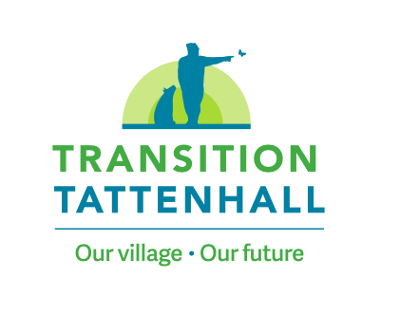
Report on Activities August 2020 – December 2021
Executive Summary
Transition Tattenhall came into being in late 2020 as a group of like-minded people who were interested in exploring how Tattenhall could become a stronger and more resilient community in the years ahead.
Through a series of roadshows we began talking to other residents to gather views on what people liked about the village, what they were less keen on and what ideas and actions they would like to see taken forward in the near and medium term. We have also been listening and learning from other communities who have been travelling in the same direction for rather longer.
Our roadshows culminated in an ‘Engagement Day’ held at the Barbour Institute in October designed to gather together interested people to discuss ideas and to come up with potential projects which the group believed could be taken forward. The major themes running through the discussions can be summarised under the headings:
- Reducing Consumption
- Biodiversity
- Community Resilience and
- Carbon Neutrality
Transition Tattenhall is now in the process of registering as a Community Interest Company which, amongst other things, will help gain access to a greater range of funding opportunities. At the same time Transition Tattenhall will liaise with other Tattenhall organisations to make sure that lines of communication are clear and that energies and knowhow are used for the greatest possible benefit to the community as a whole.
Potential early stage projects
Mini meadows across Tattenhall
Community repair and training facility
A biodiversity plan for the whole parish
Establish a strong relationship with the school and the younger generation
Establishment of an Transition Eco Hub
Campaign for better binning and recycling
Exploring options for reducing cost and extending hours of public transport

Transition Tattenhall

Report on activities August 2020 – December 2021

Aims and Objectives
Transition Tattenhall was founded to develop and support action to tackle the climate crisis, as well as the economic and social pressures currently being faced. We aim to do this through fostering a responsive, innovative, and collaborative community as well as through the establishment of local projects where shared knowledge, skills and action can build a thriving, resilient community for current and future generations.
Through these activities we hope to move towards Tattenhall having an empowered community actively involved in shaping the future of the village.

Formation, Governance & Structure
The first step in the creation of Transition Tattenhall was when, in August 2020, notices were posted in the Parish Newsletter and on Tattenhall.org inviting those interested in the idea of developing a Transition village in Tattenhall to get in touch. The interested individuals began meeting virtually and worked towards developing a structure for the organisation and establishing how best to take the ideas of Transition forward in Tattenhall.
With several later additions, this group of people became the Transition Initiating Group (TIG). TIG met regularly throughout late 2020 and early 2021 to develop the organisation’s aims and objectives, as well as an outline roadmap to a village wide event where we could engage with a large number of the local community on their vision for the future. This event later became the Engagement Day.
Another activity of TIG at this time was taking part in a Visioning exercise, where, as a group, we ran through all the aspects we like about the village, any aspects we are less keen on, and things that we would like to see in the future. This was a valuable exercise in identifying our key themes and ensuring all members were reasonably aligned in their understanding of the aims of Transition in Tattenhall. It was also a useful source of some initial project themes and ideas, as well as giving the group an understanding of the visioning process.

Engagement and Information Collection
Front of mind was always the need for this to be a village wide. It would never be a successful venture unless the village community were active participants in both the design and execution of the vision for the village and all resultant projects.
Taking this into account, there were regular updates posted on Tattenhall.org as well as pieces in the Parish Newsletter. Taking this a step further, a website was created in the summer of 2021, transitiontattenhall.co.uk, which provided a location for interested individuals to find information about the Transition Tattenhall initiative as well as links to learn more about the Transition Movement.

To further raise awareness of the group, and to interact with larger sections of the village community, a Roadshow was conceived. This comprised of a stand with branded banners along with information on what Transition was all about, and over a series of weekends and village events several TIG members would engage with interested passers-by, informing them about the idea of Transition and Transition in Tattenhall and listening to their thoughts and ideas. These ideas and suggestions were recorded and a mailing list compiled of those interested in being kept informed about the work of the group. The Roadshow was run at the first Friday at the Flacca of the year, the Annual Show, and the Church Fete as well as on several Saturday mornings on the High Street. From the Roadshows, 117 people signed up to register their interest and be kept informed of the work of the group.
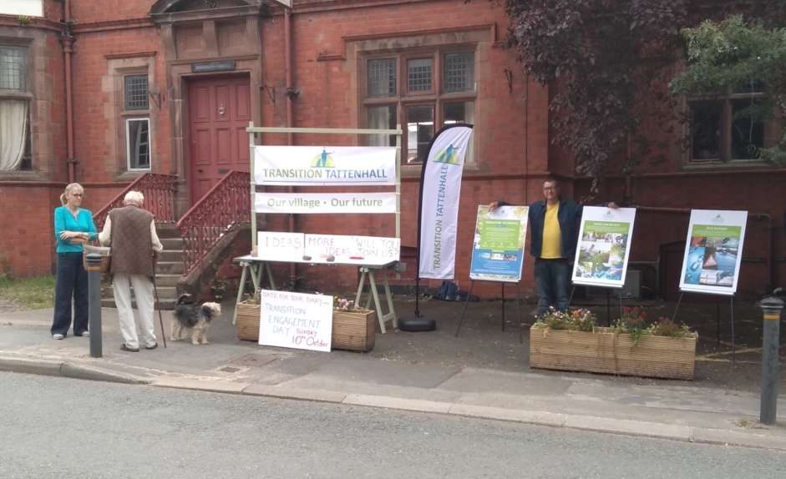
Figure 1: The Roadshow set up on Tattenhall High Street
We also began promoting the Engagement Day at these Roadshows. The Engagement Day was designed as an interactive day, with as much community participation as possible, to gather the thoughts and ideas of local residents by essentially running a visioning exercise to get an idea of aspects of the village that people like, any aspects they are less keen on, and things they would like to see in the village in the future.

Engagement Day arrived on Sunday 10th October, We had a brief introduction from 6 year old Bonnie Cooke reminding us all of the importance of protecting where we live. She was followed by Helen Tandy of Eco Communities UK who spoke of her experience starting off projects like ours and shared words of encouragement. Attendees then took part in a series of short exercises focusing on the good aspects of the village, the less positive aspects, and new things we’d like to see. These ideas were then organised into four main areas; Carbon Neutrality, Reducing Consumption, Biodiversity and Community Resilience.
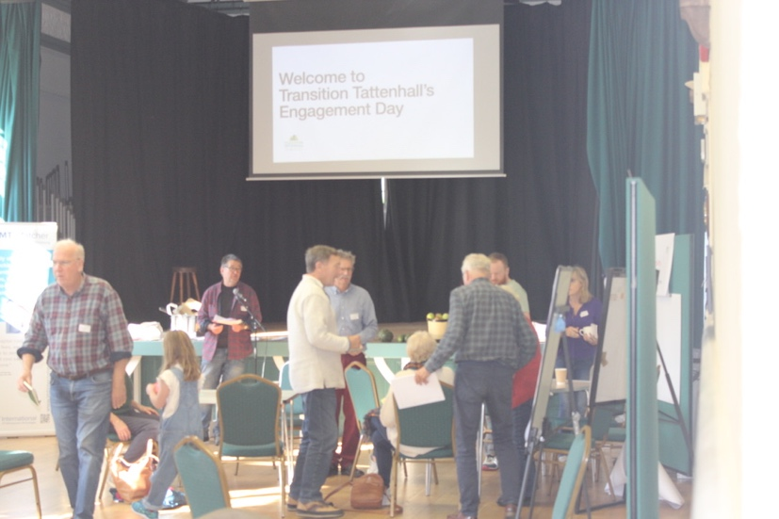
Figure 2: Engagement Day
In the afternoon, participants chose their favourite of these topic areas and came up, with ideas for projects that could address them. At the end of the day there was an opportunity to see all the project ideas from each of the topic groups and participants could vote on those they felt were particularly important. The event wound down at 3pm and, after a very collaborative day, we had generated a starter list of projects to begin moving us forward to the next phase of Transition Tattenhall.
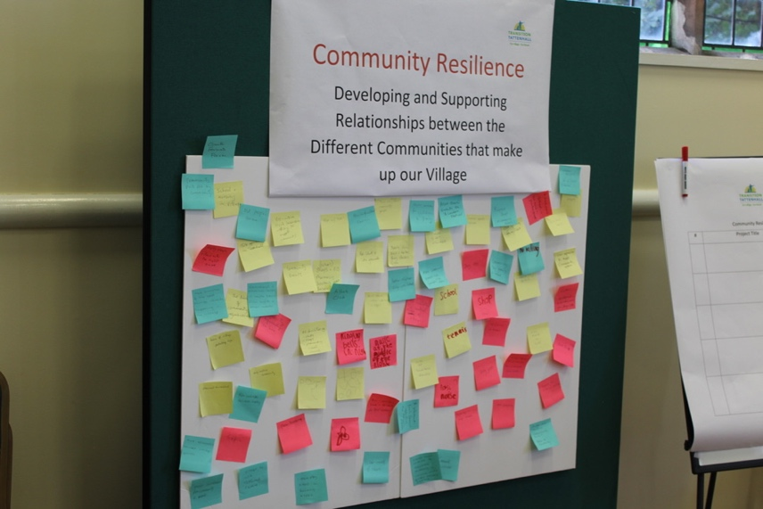
Figure 3: Thoughts and ideas captured in the morning session
To disseminate the information generated from the Engagement Day we shared a review of the day, as well as the project ideas generated, on our website, on Tattenhall.org and in the Parish Newsletter. We also held further Roadshow drop-in events at several of the village markets, as well as on the High Street, to share information about Transition, the work of Transition Tattenhall to date, and the project ideas generated at the Engagement Day.

Findings and Key Themes
Over 350 post-it notes were collected during the morning session of the Engagement Day. There were collated and provide a very valuable insight into the aspects of the village that the residents like and dislike. Some significant themes emerged as many attendees highlighted the same features of the village.
There was a high level of overlap between the topic areas, in particular community resilience and reducing consumption, but across all topic areas, the most commonly recurring features that people liked about the village were;
- The active community with a diverse selection of clubs, societies and community groups
- The sports facilities available at Sport Tattenhall
- The wide variety of shops and facilities such as pharmacy, church, Barbour Institute etc.
- Lots of trees and green space with easy access to countryside
- Good local school and nursery
- Friendly atmosphere, pleasant environment and community spirit, as well as the fact that Tattenhall is relatively self-contained
The recurring aspects that we found residents did not like were;
- The excessive number of cars, parking on the high street, unnecessarily large cars, cars parked but idling, and speeding
- Litter and dog poo
- The fence around the village green
- Noise
- Insufficient public transport
- Overly tidy gardens and verges with too much mowing
- Cutting down trees (where there are no safety issues)
There were fewer themes visible in the post-its describing ideas that people would like to see, although there was an overall higher number of suggestions in this category than for either the ’likes’ or ‘dislikes’ categories. The themes that did emerge concerned;
- Additional resources for young people e.g. a youth club and more playing areas
- The ability to purchase more local produce, a swap shop and farmers market
- Car share and improved public transport
- Better links with Gifford Lea and better use of their facilities
- Provision of education on climate change/the climate crisis and how to calculate and reduce carbon footprint

The afternoon session of the Engagement Day generated a selection of project ideas to promote one of the three topics, addressing some of the things that people had identified as desirable and/or some of the issues noted.
The projects identified were;
- Biodiversity
- A biodiverse community orchard
- Mini-Meadows across Tattenhall - Wild Weekends - Walks and Activities
- A Biodiversity Strategic Plan covering the whole parish
- Tattenhall circular walks
- Composting - help people to do their own, communal
- Reducing Consumption
- Genuinely local food market
- A village wide food strategy
- A Community market garden
- A Library of Things
- A Refill shop
- Local freecycle
- An Eco Hub
- Electric Community minibus
- Electric car charging points
- Campaign for better binning and recycling
- Easy wins action roadshow
- Village gateway signage – get people thinking local
- Community Resilience
- Reinstate the homewatch
- Develop a youth forum
- Repair the relationship with the school
- Communal gardening with garden and produce shares
- Encourage use of the Church buildings
- A community repair and training facility
- Exploring options for reducing the cost and extending the hours of transport
- Improve highway and footpath management
- Keep a whole village community event

As stated above, towards the end of the Engagement Day there was the opportunity for participants to vote on, and volunteer for, the projects that felt most important to them. 83 votes were cast and the most supported projects will form the backbone of the first group to be taken forward.
These projects are:

- Mini meadows across Tattenhall

- Community repair and training facility

- Developing a biodiversity strategic plan for the whole parish

- Establish a strong relationship with the school

- Easy wins action roadshow and newsletter

- Establishment of an eco hub

- Campaign for better binning and recycling

- Exploration of options for reducing cost and extending hours of public transport

Moving Forward & Next Steps
Transition Tattenhall is in the process of registering as a Community Interest Company. This will give the group a more formalised structure, enable it to open a bank account, and access a greater range of funding opportunities. Importantly, it also raises the profile of the organisation with stakeholders including the village community as well as funding and regulatory bodies.

Once the registration is complete and a bank account opened, the group will be eligible to apply to many more sources of funding. However, the majority of funding available is granted on a project-by-project basis meaning formal adoption of the first projects will need to be under way before this can be applied for.

The first projects to be taken forward will be those noted above as having been identified on the Engagement Day as having the most support, and the most volunteers willing to become involved. It is expected that additional support for these projects will be generated from the local community as awareness of the work increases. It is hoped that each project will gain additional volunteers and interested participants and grow beyond the numbers initially volunteering at the Engagement Day. This will be done through promotion of the projects, as well as promotion of Transition Tattenhall in general, via the organisation’s existing communications channels (website, Tattenhall.org and Parish Newsletter etc.), an increased social media presence, as well as through the increased visibility that will result from the projects being started.

As can be seen there is a wide range, in terms of scope and complexity, of projects identified. Some, such as the mini-meadows project, can be established reasonably quickly and require skills already possessed by members of the project group. This is important as successful, quick completion of such visible projects will raise the profile and awareness of Transition Tattenhall as well as providing all the benefits of the project itself. Other projects, such as developing a community repair and training facility will take longer to establish due to the scope of the project and the specialist knowledge and skills required for successful completion.
The next stage in taking these projects forward is for the various project groups to meet and begin to plan out their projects. Transition Tattenhall will provide guidance and support, where required, on planning considerations such as the knowledge, skills and any financing required. We will also develop a framework enabling the various project groups to report back to TIG with their progress and request assistance where necessary.

The intention is for future project ideas to be generated from within the wider Tattenhall community. These ideas would be brought to the Transition Tattenhall group and if deemed to align with the mission and values of the organisation would be promoted through our communication channels. If sufficient interest and support is present then the project would go ahead, with guidance and support provided by Transition Tattenhall as for the first batch of projects. Progress reporting would also follow the framework being developed for this first group of projects. There is also scope for further village wide collaborative events such as the Engagement Day to be held.

Concurrently to the initiating of the project phase, development of a strategic plan is required to fill the existing gaps in coverage, expertise, and stakeholder groups. The absence of any specific projects addressing carbon neutrality is a noticeable gap, especially considering the stated aims of the organisation. From feedback received, it is felt that this topic was considered almost ‘too big’ to deal with on the Engagement Day with attendees preferring to focus on smaller scale, more tangible aspects of Transition. However, many of the thoughts and project ideas generated from the other three discussion groups do impact on Carbon Neutrality, for example better insulated homes. So, while the assumption prevails that to address carbon neutrality, large village wide projects are required such as Community led energy projects, several of the projects due to be started do in fact impact on carbon neutrality.
It is also the case that the more awareness of Transition Tattenhall increases, and the more successful projects we can point to, the more confidence and willingness people will have to get involved in the bigger projects.
Similarly, links need to be forged with local businesses to include this important local group in the future of Transition work.

